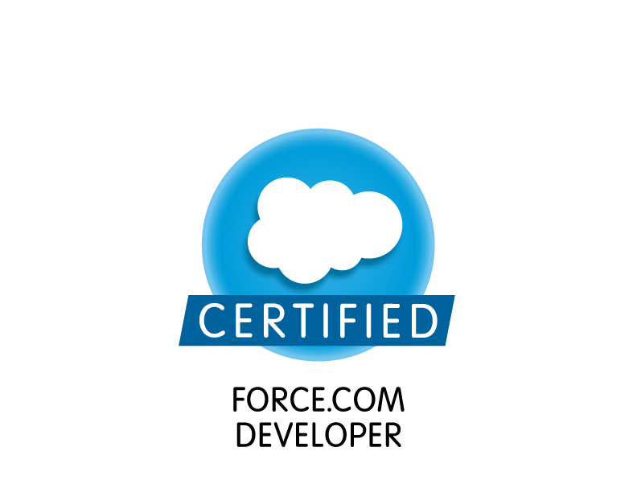

PANDUGA GAJENDER REDDY

E-Mail: pandugagajenderreddy@gmail.com Mobile: +91 7022570499

Aiming for jobs in software Industry with a leading organization

- A 401 salesforce.com certified force.com Developer.
- Qualified Computers Engineer with over 7 years of experience as Software Engineer and Technical Support Engineer in the IT Sector.
- Presently associated with Wipro Technologies(on contract) Bangalore as Sr. Software Engineer
- Experience in Administration, Configuration, Implementation and Support of sales force CRM and sales force SFA applications based on Apex Language and leveraging Force.com Platform world’s first commercial Software as a Service (SAAS) application running in Cloud Computing Environments.
- Implemented security and sharing rules at object, field, and record level for different users at different levels of organization. Also created various profiles and configured the permissions based on the organizational hierarchy.
- Designed various Webpage’s in Visual Force for capturing various customer enquiries and Implemented logic for migrating cases to different queues based on the type of customer enquiry.
- Worked on the designing of custom objects, custom fields, role based page layouts, custom Tabs, custom reports, report folders, report extractions to various formats, design of Visual Force Pages, Dashboards, Apex Classes, Controllers & Triggers, VF Components and various other components as per the client and application requirements.
- Adept in developing, testing, documentation and implementation with solid understanding of Relational Databases and III-Tier Architecture.
- A team player with good communication, analytical, logical and problem-solving skills.

SKILLS SET

Technical:
Visual Force, Apex, C, HTML, MySQL 5.0, SQL Server 2005, SQL Server 2008, C#.NET, DHTML ADO.NET, ASP.NET, SQL, MS Office and IIS 5.1,

Functional:

- Creating test plans, test cases and test scripts/procedures for carrying out tests of the software at various stages in the SDLC.
- Verifying change requests and defects; documenting, tracking and communicating test plans, test results and unresolved problems; preparing test reports.
- Handling smooth implementation of the project at client location.
- Extending post-implementation, application maintenance and technical support to the client.
- Conducting system study and coordinating with team members for System Design & Integration, Application Maintenance, etc.
- Handling various technical aspects like software design, coding of modules, monitoring critical paths & taking appropriate actions.

WiproTechnologies (Contract, Parent Company – Future Focus Infotech Pvt Ltd), Bangalore as Salesforce CRM Consultant Dec’14-till date

Astoria Technologies (www.astoriatechnologies.com), Hyderabad as Sr.Software Engineer May’10-Nov’14

Bridle IT Solutions (www.bridleit.com), Hyderabad as Software Programmer Dec’08-April’10

CAREER RECITAL

Current Employer : Wipro Technologies, Bangalore

Project #1
Title : BAXTER Healthcare (HLS)
Role : Saleforce CRM consultant
Team Size : 4
Duration : Dec 2014 – till date
Environment :
Saleforce.com platform, Apex, Visualforce, Salesforce.com Data Loader, Workflow & Approvals, Reports, Custom Objects, Custom Tabs, Security Controls, HTML, Sandbox, Change set.

Responsibilities:

- on customization of Page Layouts, Field Level Security, Organization Wide Defaults and Sharing rules, Profile Settings, Validation rules and Workflows
- Configuration of Salesforce.com - creating fields, objects, Validation rules, Workflow rules, Custom Settings etc.
- Worked on Standard Objects like Event, Task, Account, Contact and Opportunity and customized it further to map business requirements for multiple country.
- Implemented Translation workbench and territory management solutions
- Trigger Development using Apex Programming
- Apex Classes and Visual force pages Creation to design few of Sales Process for Targeting different hospitals and doctors and managing their visit records.
- Creation of Technical Design document
- Creation of Mapping file involved in data loading
- Creation of test Classes for Apex Classes and Triggers
- Migration of data and configuration files from one instance to another
- Worked with third party health care data provider like Cegedim and Binleys and helped on integration of their system with Salesforce for daily data flow.

Since May’ 2010 : Astoria Technologies India Pvt Ltd (www.astoriatechnologies.com).

Designation : Sr.Software Engineer.
During : May 2010 to Nov 2014.

Astoria Technologies is a leading business consultancy and IT solutions provider for the marine industry located in Singapore, to help customers increase revenue, lower cost and increase efficiency with customized scheduling software solution/s for shipyards and marine contractors based on their scale of operation and software investment budgets. New releases are made live in the shortest time possible. Users begin exploring new features immediately upon launch. The feedback cycle is quick. We use Agile development practices and use a constantly evolving, lean software development process.

Project #1
Title : Astor Job
Role : Sr. Software Engineer
Team Size : 10
Duration : Sep 2014 – Nov 2014
Environment :
Saleforce.com platform, Apex, Visualforce, Salesforce.com Data Loader, Workflow & Approvals, Reports, Custom Objects, Custom Tabs, Email Services, Security Controls, HTML, Java Script, Java, Web Services, Sandbox, Eclipse IDE Plug-in.

Description:
AstorJob is an end to end job solution product for Marine Industry, Developed to organize their Activities and Manpower Scheduling with ease .This application processes all the information related to service the ship from the time it arrival to the time it dispatch like Delivery Management, Manpower Management, Purchase orders, Quotations, Customer Management.

Responsibilities:
• Creating and managing user with security settings.
• Generation reports with Dashboards.
• Managed team to implement the documented requirements and reports, assisting in all configuration activities.
• Coordinated work assignments with developers and Administrators throughout the product development life cycle.

Project #2
Title : Material Management
Role : Sr. Software Engineer
Team Size : 12
Duration : Feb 2013 – Aug 2014
Environment:
Salesforce.com Platform, Salesforce.com Custom Objects, HTML, Java Script, Workflows, Reports, Eclipse, Force.com Eclipse Plug-in, SalesForce.com sandbox

Description:

Material Management is an application which helps in managing the inventory required for shipyards .It consist of modules like Purchase Requisition, Purchase Orders, Goods Received, Goods issued and so on which helps in managing the inflow and out flow of material at any point of time.

Responsibilities:
• Performed the role of Business Analyst, interacted with various business user groups for gathering the requirements for salesforce.com CRM implementation.
• Documented and shared the requirements with SalesForce.com consultants for further implementation.
• Closely worked with SalesForce.com consultants while implementing the solutions for the needs of organization.
• Customized the Dashboards to the track usage for productivity and performance of business centers and their sales teams.
• Customized tabs for among different business users groups and business centers.
• Create various profiles and configured the permissions based on the organizational hierarchy requirements of Hotwire.
• Created the workflows for automated lead routing, lead escalation, alerts and custom coaching plans.
• Developed Apex Classes & Triggers and linked them to manage the workflows developed in the system.
• Developed various Custom Reports and deployed them for different business user levels.
• Provided the training to the internal business users to use the application and develop their own custom reports.
• Performed the role of support engineer for the internal users and helped them in getting used to the application, generated reports and saved them for further access to the users.
• Involved with Salesforce.com Premier Support and handled the support cases with the help salesforce.com support.

Project #3

Title : AstorYard
Role : Sr.Software Engineer
Team Size : 8
Duration : May 2011 – Jan 2013
Environment:
.Net Framework 4.0, C#, WCF, SQL server 2008, Windows XP.

Description:
AstorYard is an end to end job solution product for Marine Industry, Developed to organize their Activities and Manpower Scheduling with ease .This application processes all the information related to service the ship from the time it arrival to the time it dispatch like Material Management, Delivery Management, Manpower Management, Purchase orders, Quotations, Customer Management ,Inventory Management and etc.

Responsibilities:

- Designing the flow of the page.
- Managing the team to accomplish the targets in time .
- Database Activities like creating Tables, Stored Procedures, Functions etc.. using
MS Sql Server,
- Development of Middle Tier Component like Business Layer.
- Preliminary testing of the tasks.

Project #4

Title : Safe Smart Period: Apr’11-Aug’11
Role : Sr.Software Engineer
Team Size : 4
Duration : May 2010 – Apr 2011
Environment : .Net Framework 4.0, C#, WCF, SQL server 2008.
Operating System : Windows XP

Description :

The main objective of the Safe Smart Application was to empower workforce safety and accountability in the Oil & Gas industry. Safe Smart was a holistic system of using RFID sensors and software to pin-point the exact number and location of the workers in an unobtrusive way Safe Smart provides interface to control access and monitor occupancy of confined spaces on the individual vessels and issues alerts whenever defined safety limits are exceeded.

Responsibilities:

- Designing the flow of the page.
- Managing the team to accomplish the targets in time .
- Database Activities like creating Tables, Stored Procedures, Functions etc.. using
MS Sql Server,
- Development of Middle Tier Component like Business Layer.
- Preliminary testing of the tasks.

Since Dec’ 2008 Bridle Information Technology Pvt. Ltd., Hyderabad (www.bridleit.com)

Significant Highlights
- Managed activities for identifying operational malfunctions with new product line – reproduce, troubleshoot, and configure the problem to pinpoint and implement solution.
- Effectively managed and implementation of cost-effective training and support solutions that are designed to provide improved productivity, streamlined operations, and faster access to critical information. Managing the Database and IIS for better performance.
- Implemented effective customer satisfaction strategies by identifying and eliminating the root causes of customer problems. Provide comprehensive system and product support, configuration, maintenance, and training for staff and promoted value features for existing clients. Performed hardware and software installations and provided high-level customer care, training, and technical support.

Key Projects Handled
Title: Fee Management System Client: Educational Institutions
Duration: August 2009 to April 2010 Team Size: 4
Environment: ASP.NET 2.0, MSXML4.0, XSLT and Javascript, MySQL, Yahoo User Interface, Windows 2003 Server, Windows XP
Scope: It provides complete solution for Fee Management System. It’s one of the modules in SchoolMATE product. Designed data base schema for Fee management system. Its provides Fee Transactions of an Institution for various Organizations with in the Institution . Tracks all the information like Fee Dues, Fee Payments by Different Modes, Fine , Excess Payments, Scholarship and Concessions of student. Designed various Reports on Day, Month and Year Fee Transaction of Organization. Designed Schema for merging fee transactions into accounts.

Role: Developer
Title: Multi Messaging Solution Client: SchoolMATE Clients
Duration: January 2009 – June 2009 Team Size: 2
Environment: ASP.NET 2.0, C#.NET, MySQL, Windows 2003 Server, Windows XP
Scope: Web based Multi Messaging Solution designed & developed by Bridle IT Solutions using C#.Net to setup the communication environment seamlessly. MMS can deliver SMS messages unimaginably to any mobile enabled devices. MMS is a web based application through which we can send Bulk amount of messages and Customized Messages. The input can be from Excel. This MMS is connected to third party Internet Gateway to send Messages.
Role: Developer

Title: SchoolMATE (EES) Client: Educational Institutions
Duration: Dec 2008 to April 2010 Team Size: 6
Environment: ASP.NET 2.0, MSXML4.0, XSLT and Javascript, MySQL, Yahoo User Interface, Windows 2003 Server, Windows XP
Scope: It provides complete solution for any Educational Management System, right from Admission Management to Examinations Management. Keeps track of every activity about the student viz. his Absence information, progress reports, exam schedules, fee payment dues, Staff Attendnace integrated with Bio Metric,Student Transportation enabled with GPS Device, Library,important events and much more are communicated to the parents to empower them with RIGHT INFORMATION about their Child at the RIGHT TIME directly to their mobiles as SMS with the help of SMSC and to their e-mail accounts.
Role: Senior Technical Support

SCHOLASTICS

2006 B.CA. Computer Applications from IGNOU
2001 HDSE. Higher Diploma in Software Engineering from APTECH

PERSONAL VITAE

Date of Birth: 10th June 1981
Current address: H No: 51, LK Residency,Veerappa Reddy layoout, Munnekolala, Marathahalli, Bangalore, Hyderabad – 560037.
Permanent Address: (Post) Janampet, (Mandal) Addakal, (Dist) Mahabubnagar – 509382
Passport Number: K 4762686
PAN Number ALJPR4849N
Martial Status: Married

Place: Bangalore
Date: 24/09/2016

